User Guide

## Background:

Industries demand a change of the traditional education to increase technical skills on the graduates due to the development of new technologies. Also, COVID 19 has accelerated this necessity. In consequence, the increase of unemployment rates specially for the recent college graduates.

Currently, there isn't any online platform that does both training and placement for colleges students who haven't job experience that's the main reason to create a platform that be able to nourish students throughout their journey and help them reach their first dream job.

## Details:

**Auto recommendation** - The algorithms created will give the student accurate recommendations in jobs and trainings based on their background and preferences. The recommendation algorithm grows with the user journey.

To get access of the full potential of the app, students must have the premium plan. In order to get this feature:

1. When you sign up, on the next screen you will have to choose the category of your interest. You can choose up to 3 categories at the same time
2. The next screen will show personalized content based on your preferences and your background. The background information will get when you sign up.
3. 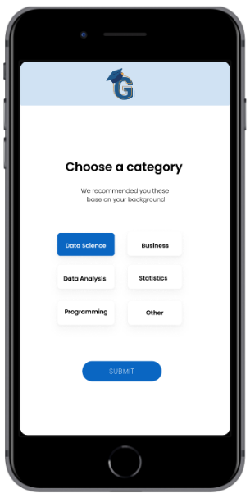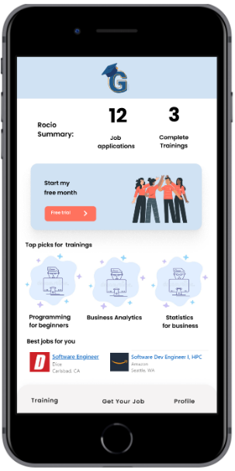If you are a premium user, you can change categories at any time. Free version users only can choose one category and cannot change it.

**Personalized mentoring** - Students can connect with mentors, get personalized responses based on their preferences and goals. The mentoring session will last 2 months and the student can choose to have up to 4 mentors per year.

In order to get this feature:

1. When you sign in, go your Training screen.
2. On the mentoring screen you will see the best options based on your preferences and goals that you have for your professional grow.
3. If you are a premium user, you can get up to 4 mentors per year. Free version users only can see the mentors but not connect with them.

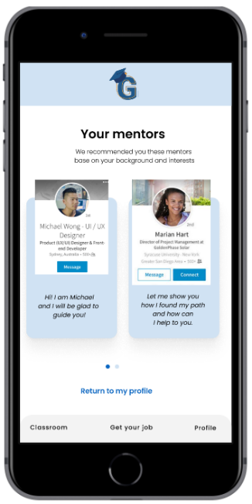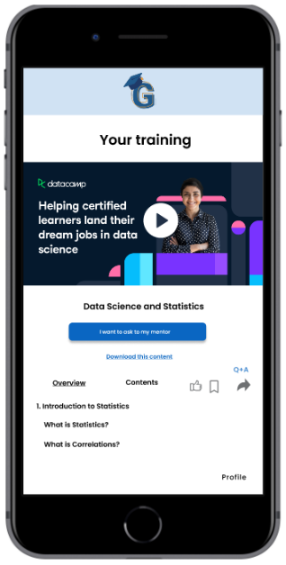

**Offline developing** - To facilitate the student learning journey, the feature will provide the choice to do some trainings or courses offline, also download and do it offline.

